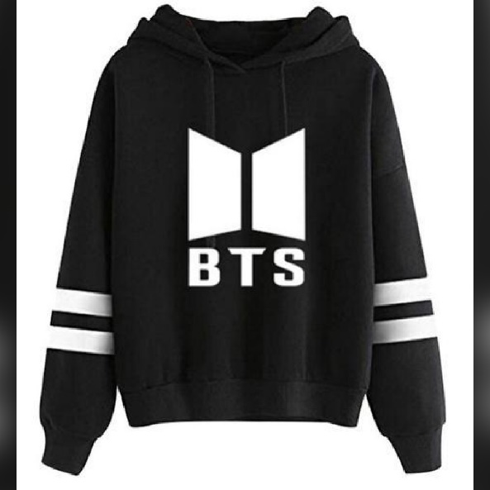

BTS Double Strip Pull Over Fleece Hoodies For Men

Product details of BTS Double Strip Pull Over Fleece Hoodies For Men

* Soft
* Trendy
* Stylish
* Comfortable
* Premium quality
* High quality Cotton material, machine or hand washable,100% pure cotton
* Regular fit, special for women Winter wear, Export quality stitching and material.

Specifications of BTS Double Strip Pull Over Fleece Hoodies For Men

* Brand

Jack Beos

* SKU

101849855_PK-1247475684

* Neckline

Hooded

* Clothing Style

Fashion

* Hoodie Style

Pull Over

* Jacket Closure Type

Pullover

* Main Material

Fleece

* Clothing Material

Fleece

* Express delivery

Karachi

* Sleeve Length

Full